**AWS AND LINUX PROJECTS**

**AGENDA :** THIS PROJECT IS SHOWING HOW TO DO WEBHOSTING IN LINUX ON AWS .

**TECHNOLOGY :**

* EC2
* LINUX
* HTML
* NGNIX

**STEP1 :-**

LOGIN TO THE AWS AND GO TO THE EC2 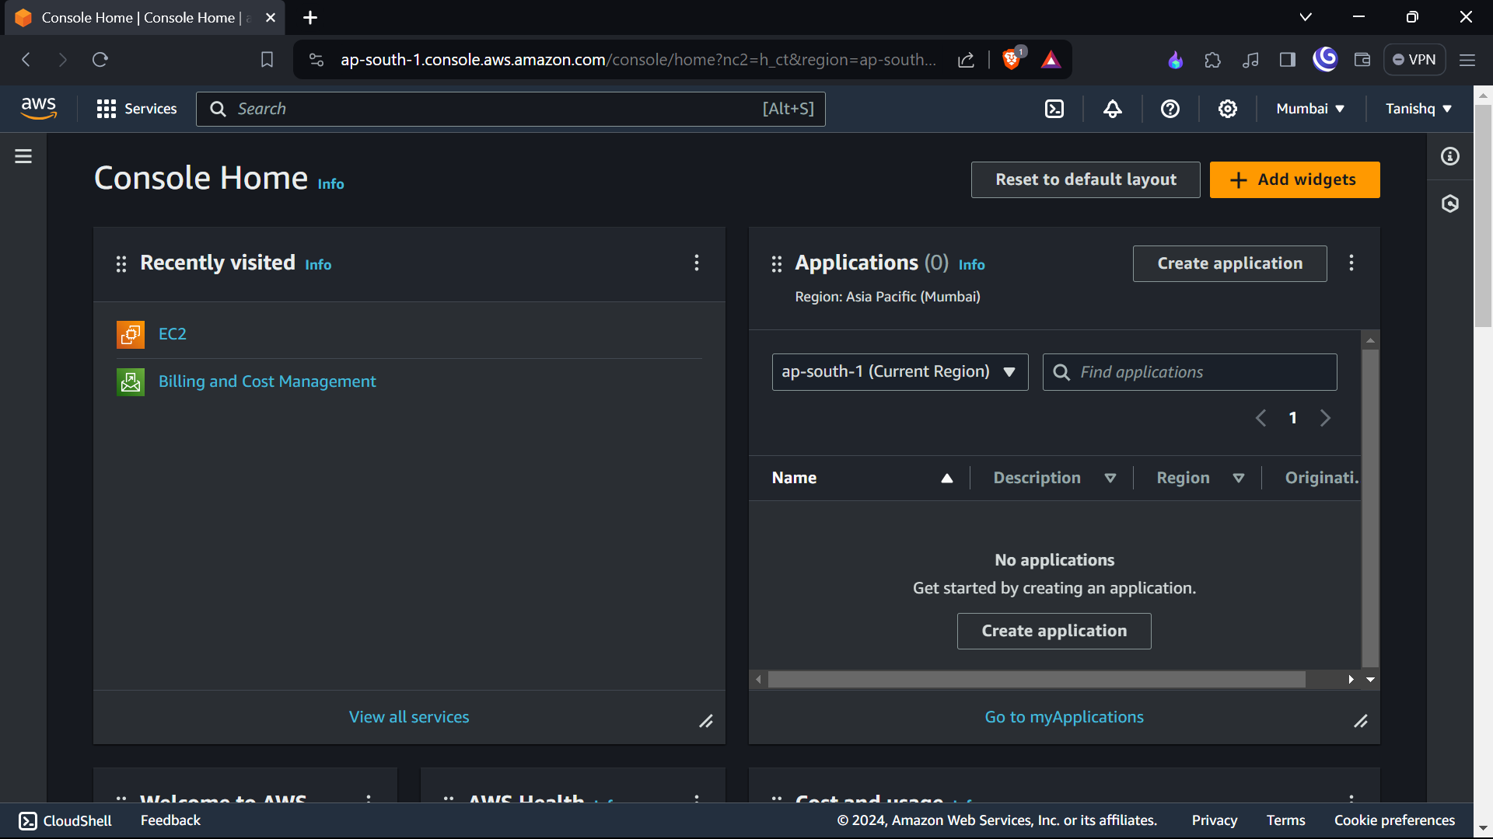

**STEP2:-**

WE LAUNCH INSTANCES ON EC2 OF UBUNTU LINUX

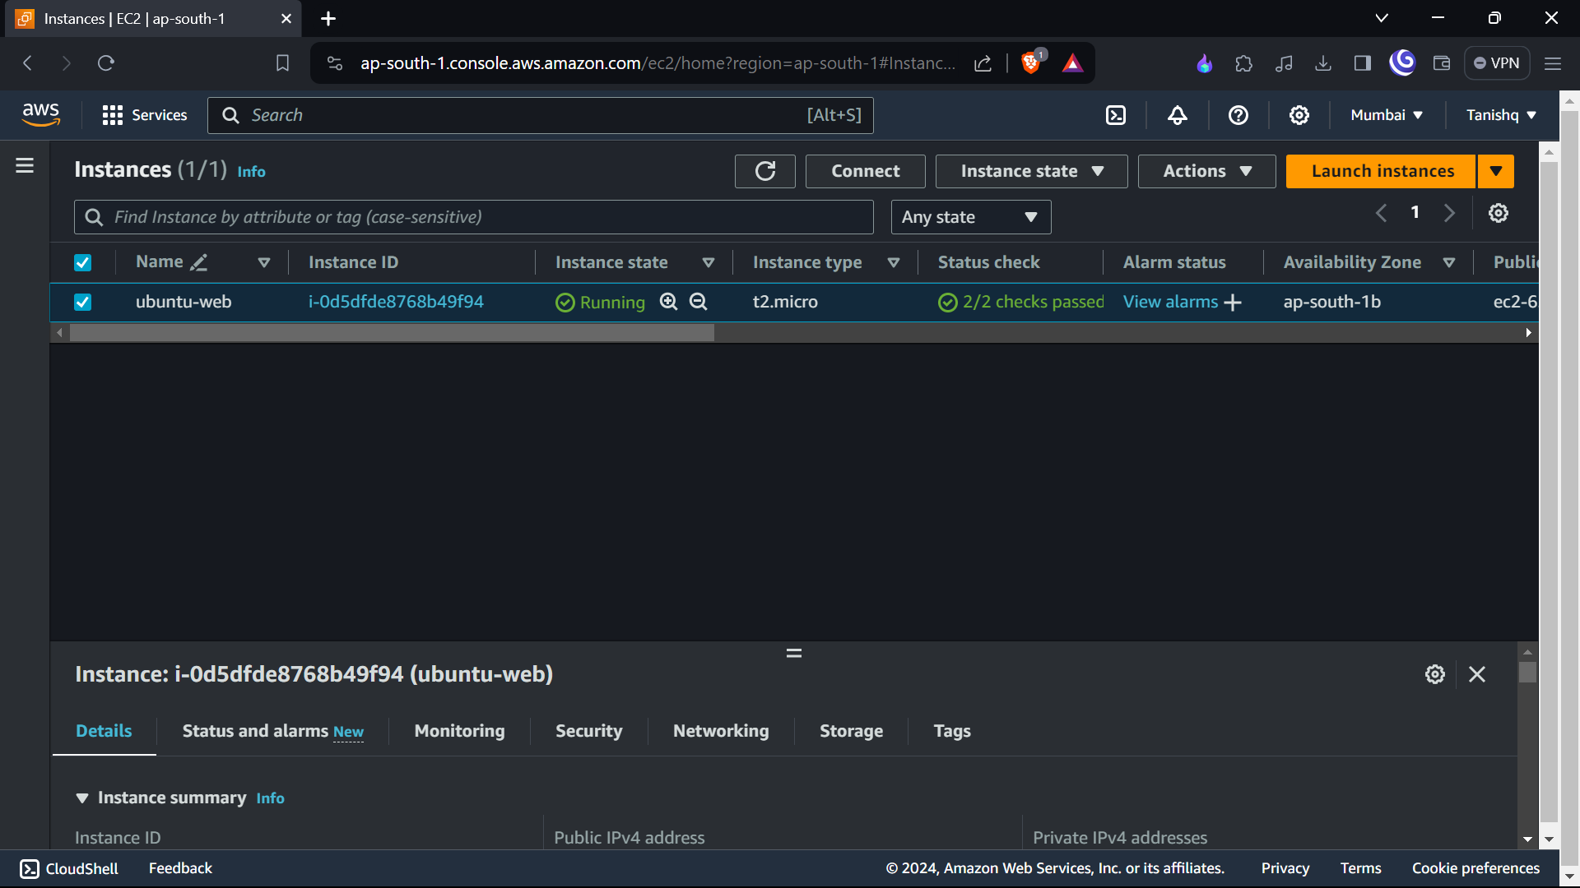

**STEP 3 :-**

THEN CONNECT TO THE INSTANCE AND REACHED TO LINUX SERVER

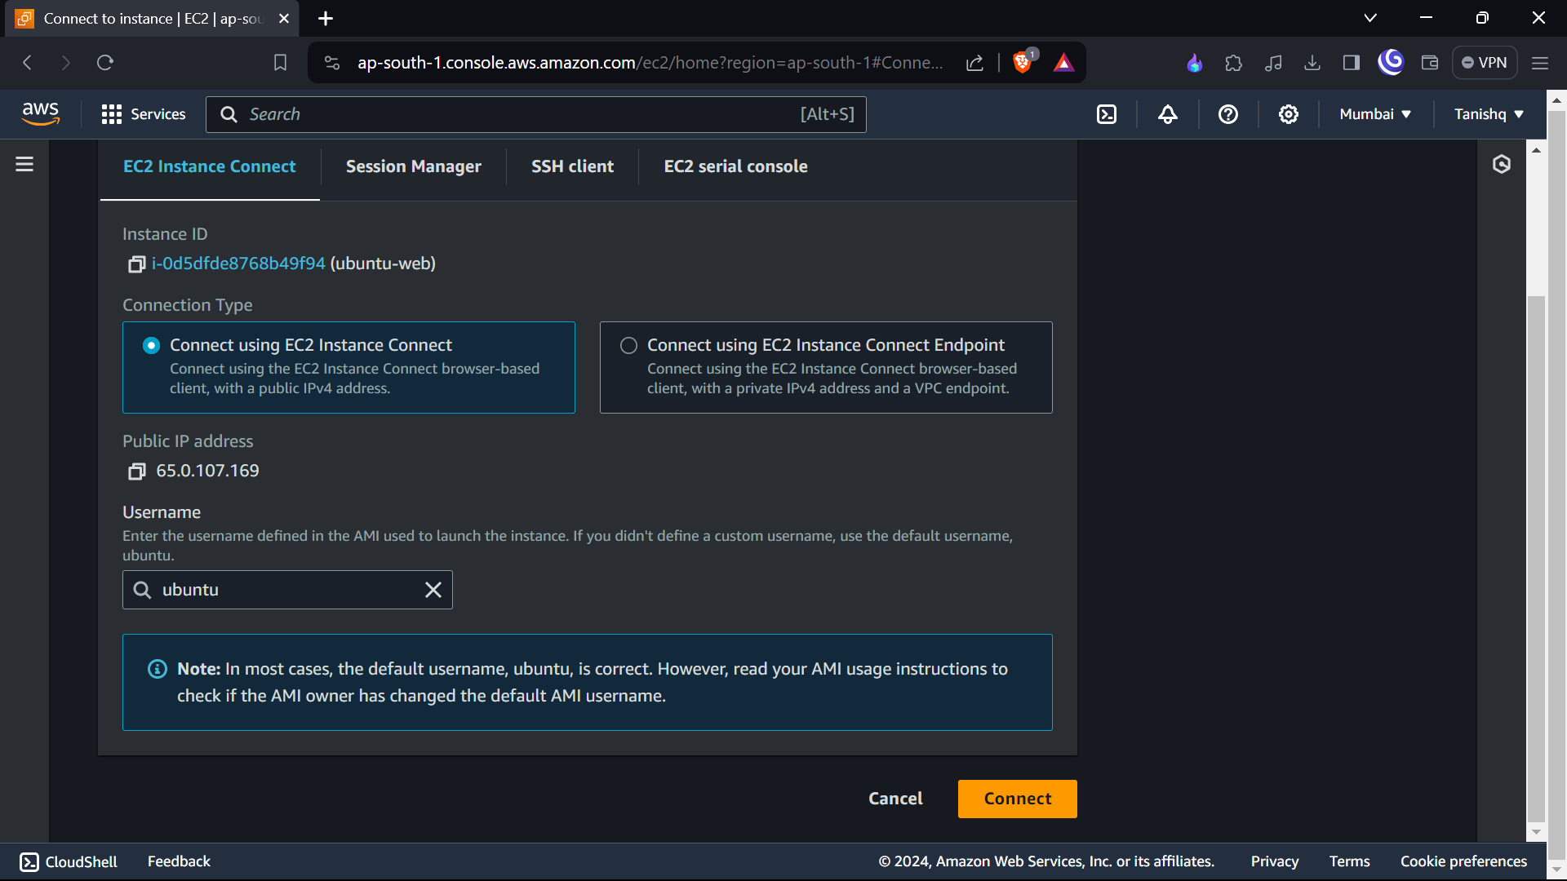

**STEP 4:-**

WE REACH TO THE LINUX SERVER AND GO TO THE SUPER USER AND GET UPDATE

* Sudo su
* Apt update

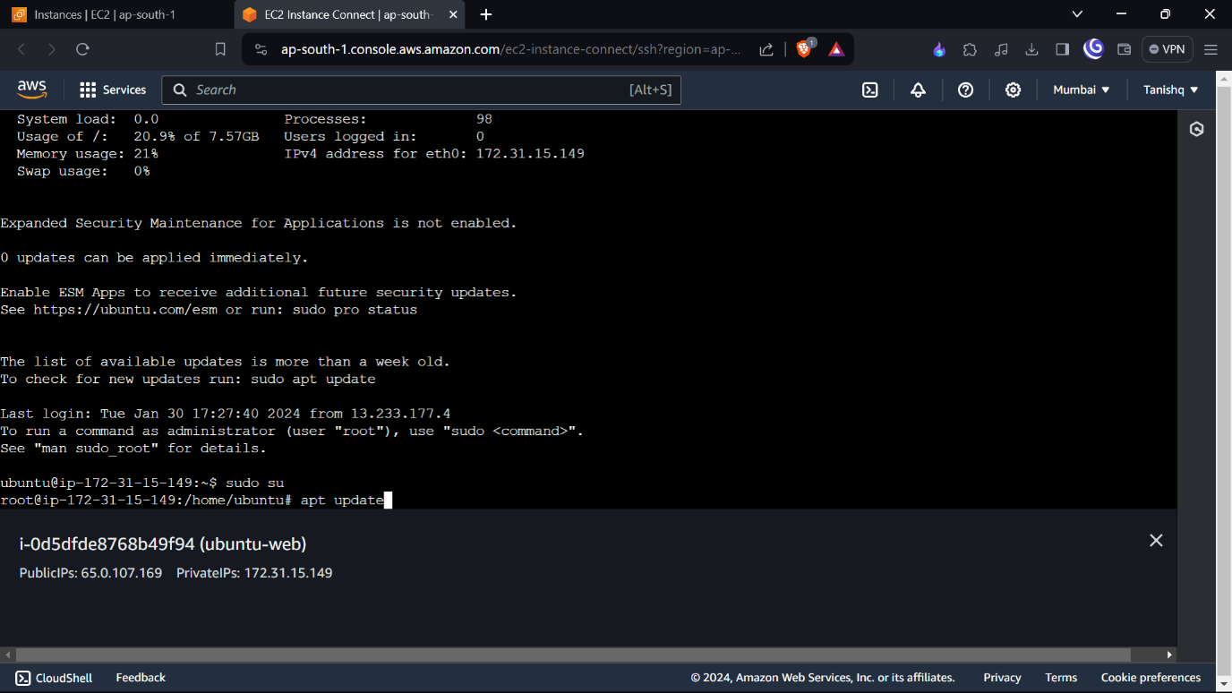

**STEP 5:-**

INSTALL TO NIGNIX SERVER

* Sudo yum install ngnix -y

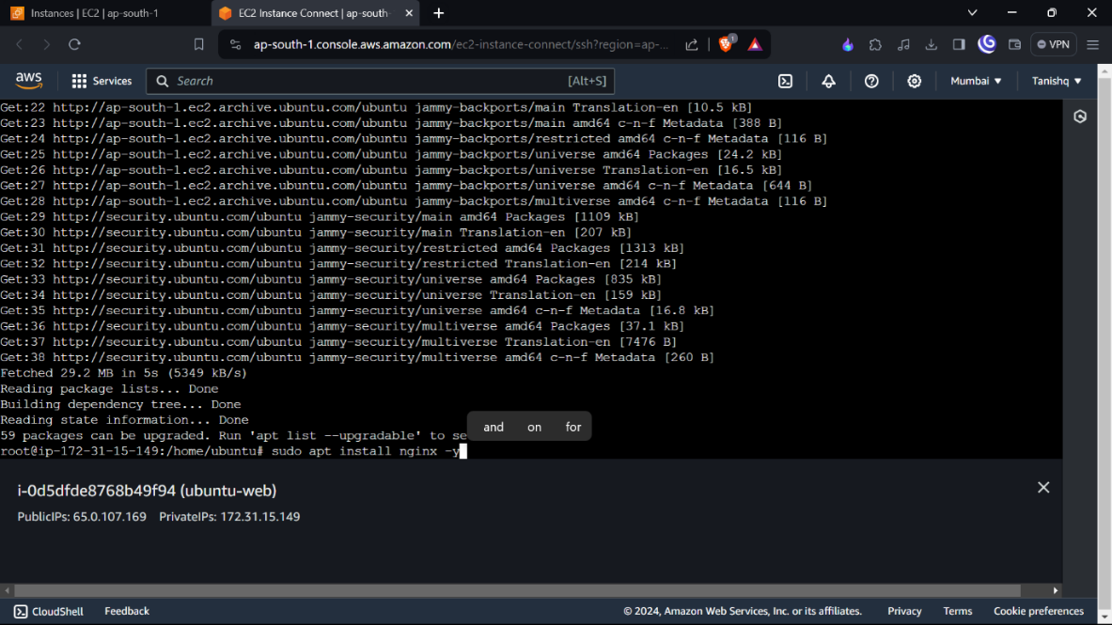

**STEP6:-**

**SEE THE NGNIX**

Vim /var/www/html/

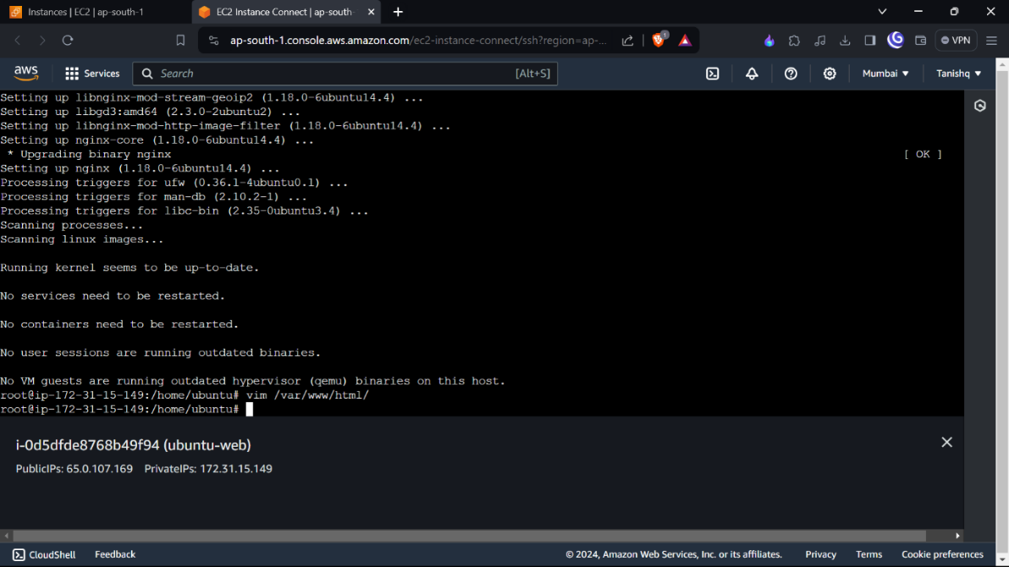

**STEP 7:-**

THIS IS NGNIX SERVER

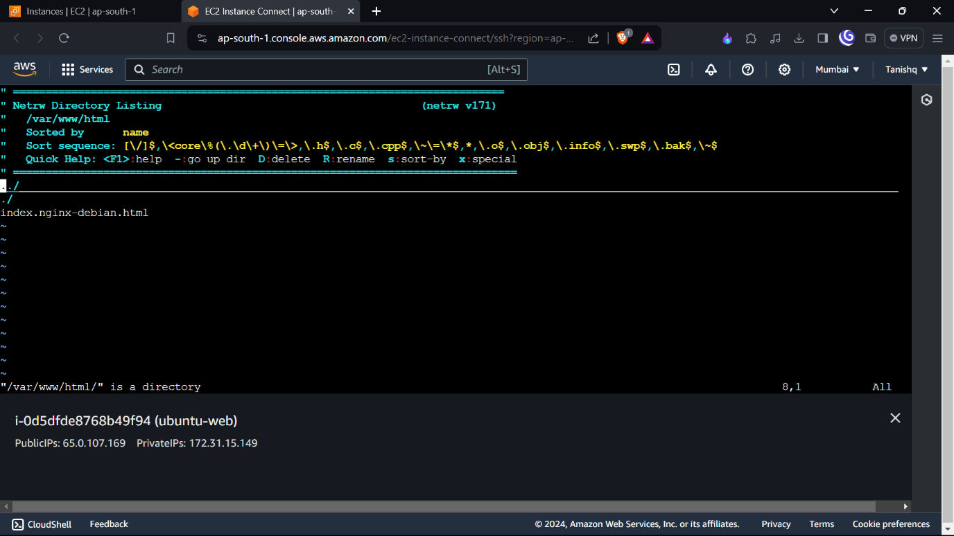

**STEP 8:-**

**GO IN THE WWW DIRECTORY**

Cd /var/www

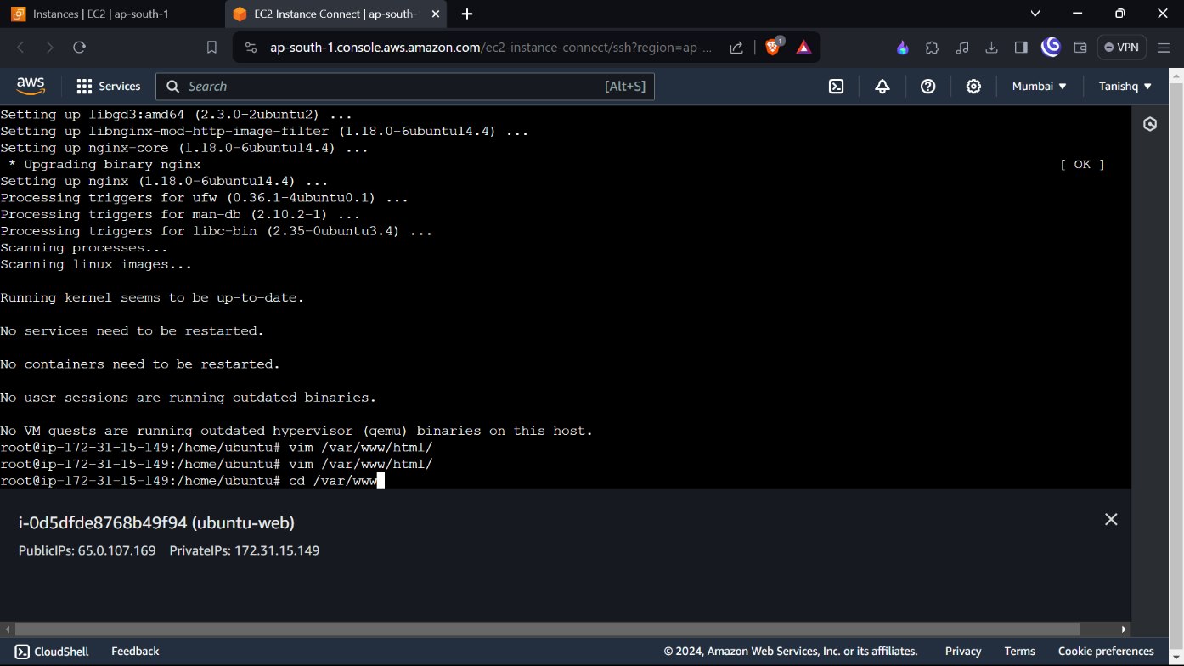

**STEP 9:-**

**MAKE A DIRECTORY (PROJECT1) AND GO INTO THAT**

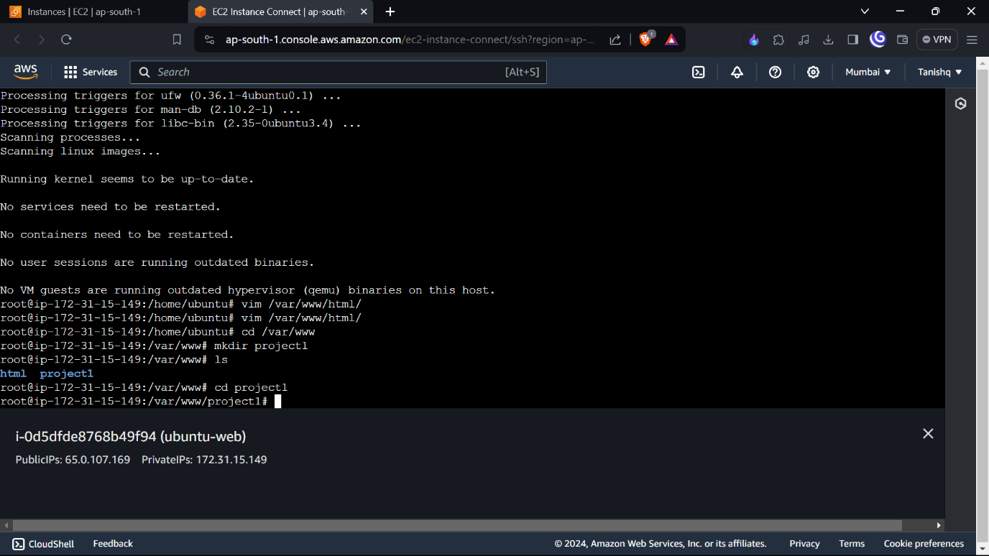

**STEP 10 :-**

CREATING OUR OWN WEBSITE

WE MAKE HTML FILE (WEBHOSTING.HTML) AND ENABLED SITES

* Vim webhosting.html
* Cd /etc/nginx/sites-enabled

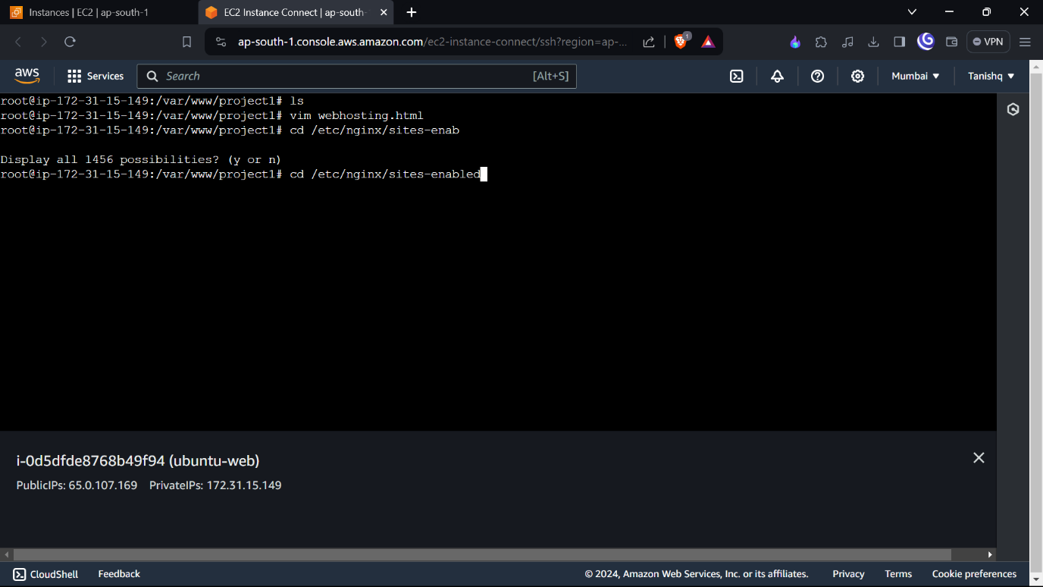

**STEP11:-**

UPLOAD THE HTML CODE AND SAVE IT

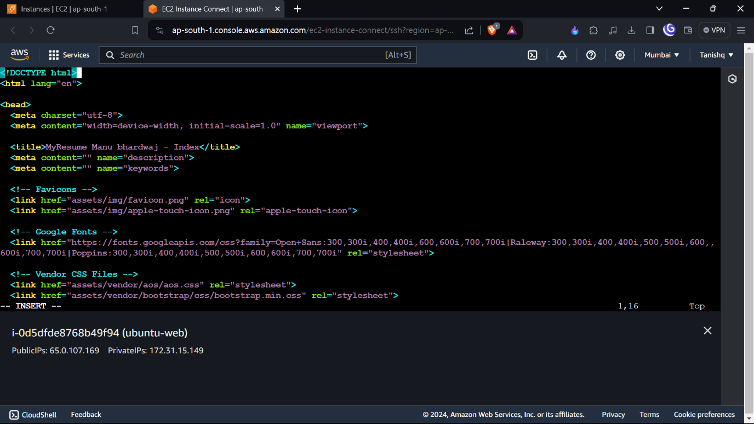

**STEP 12 :-**

**IN THIS CREATE A FILE (PROJECT1)**

Vim project1

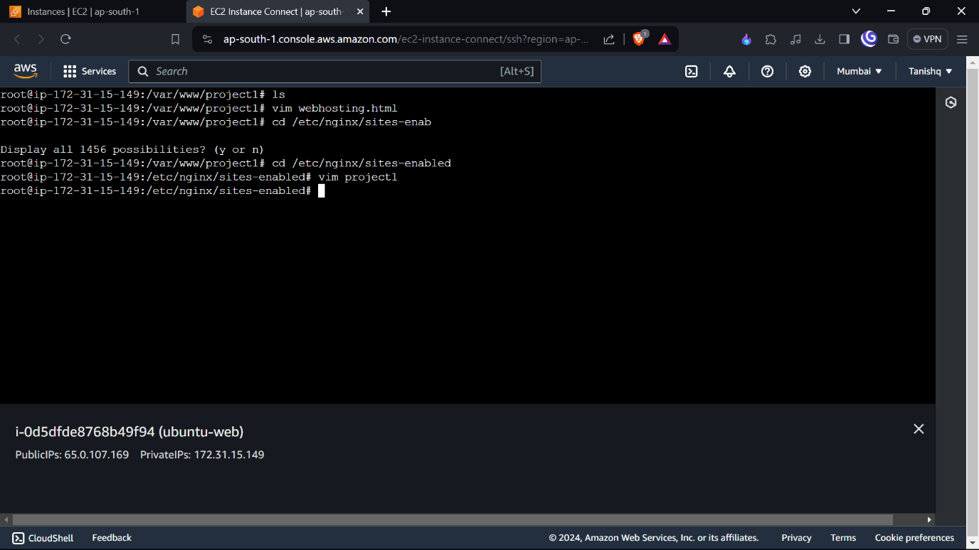

**STEP 13 :-**

TO SET UP VIRTUAL HOST

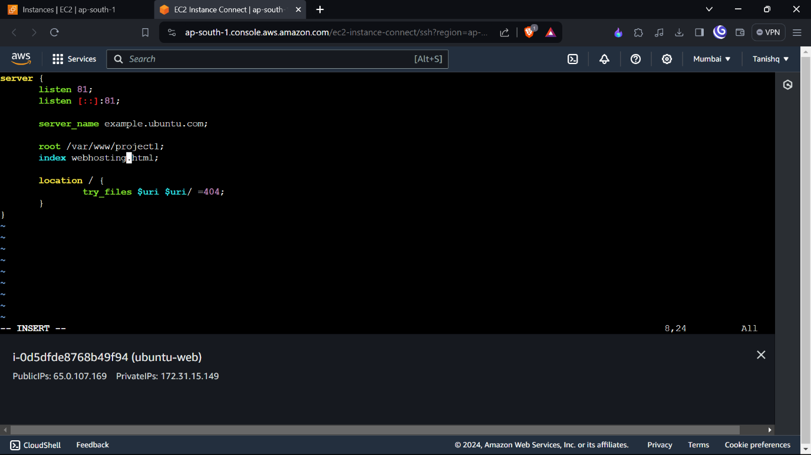

**STEP 14 :-**

## ACTIVATING VIRTUAL HOST AND TESTING RESULTS

AND RESTART THE SERVICE NGINX

* Sudo service nginx restart

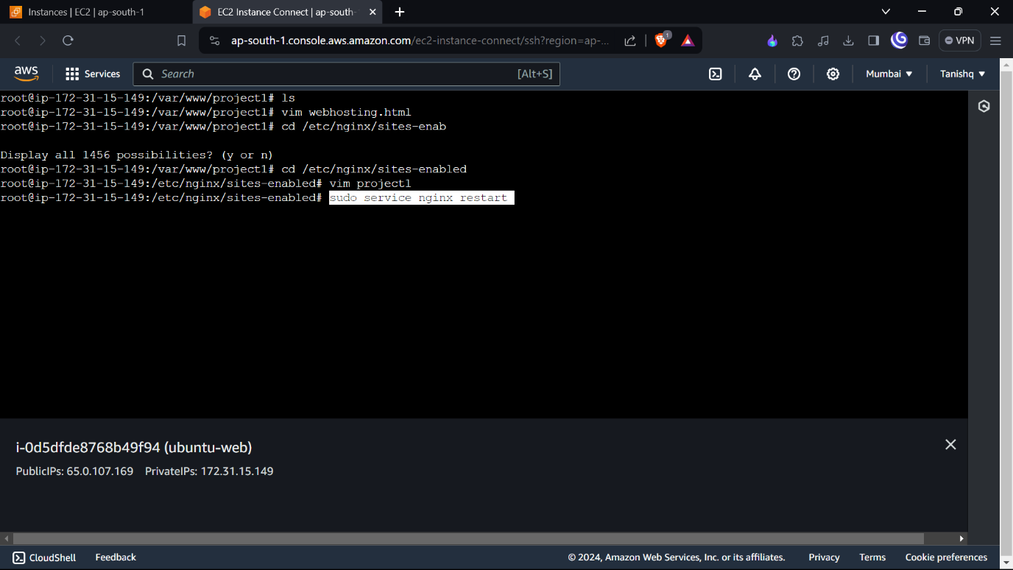

**STEP 15 :-**

SEE OVER WEBSITE

* Curl localhost:81

